Day 5 - 28th May 2025

Operating System Fundamentals
Linux
Linux Fundamentals

Linux Basics , Introduction to System Access and File System, Linux Command Syntax, Files and Directory Permissions (chmod), File Permissions Using Numeric Mode, File Ownership Commands (chown, chgrp), Access Control List (ACL), Help Commands, TAB Completion and Up Arrow Keys, Adding Text to Files, Input and Output Redirects (>, >>, <, stdin, stdout and stderr), Standard Output to a File (tee command), Pipes ( | ), File Maintenance Commands (cp, rm, mv, mkdir, rmdir), File Display Commands (cat, less, more, head, tail), Filters / Text Processing Commands, cut - Text Processors Commands, awk - Text Processors Commands, grep/egrep - Text Processors Commands, sort/uniq - Text Processors Commands, wc - Text Processors Commands, Compare Files (diff and cmp), Compress and uncompress (tar, gzip, gunzip), Truncate File Size (truncate), Combining and Splitting Files, Basics of System Administration & Networking

To check if linux is installed in your windows 👍
Go to cmd and type wsl –version

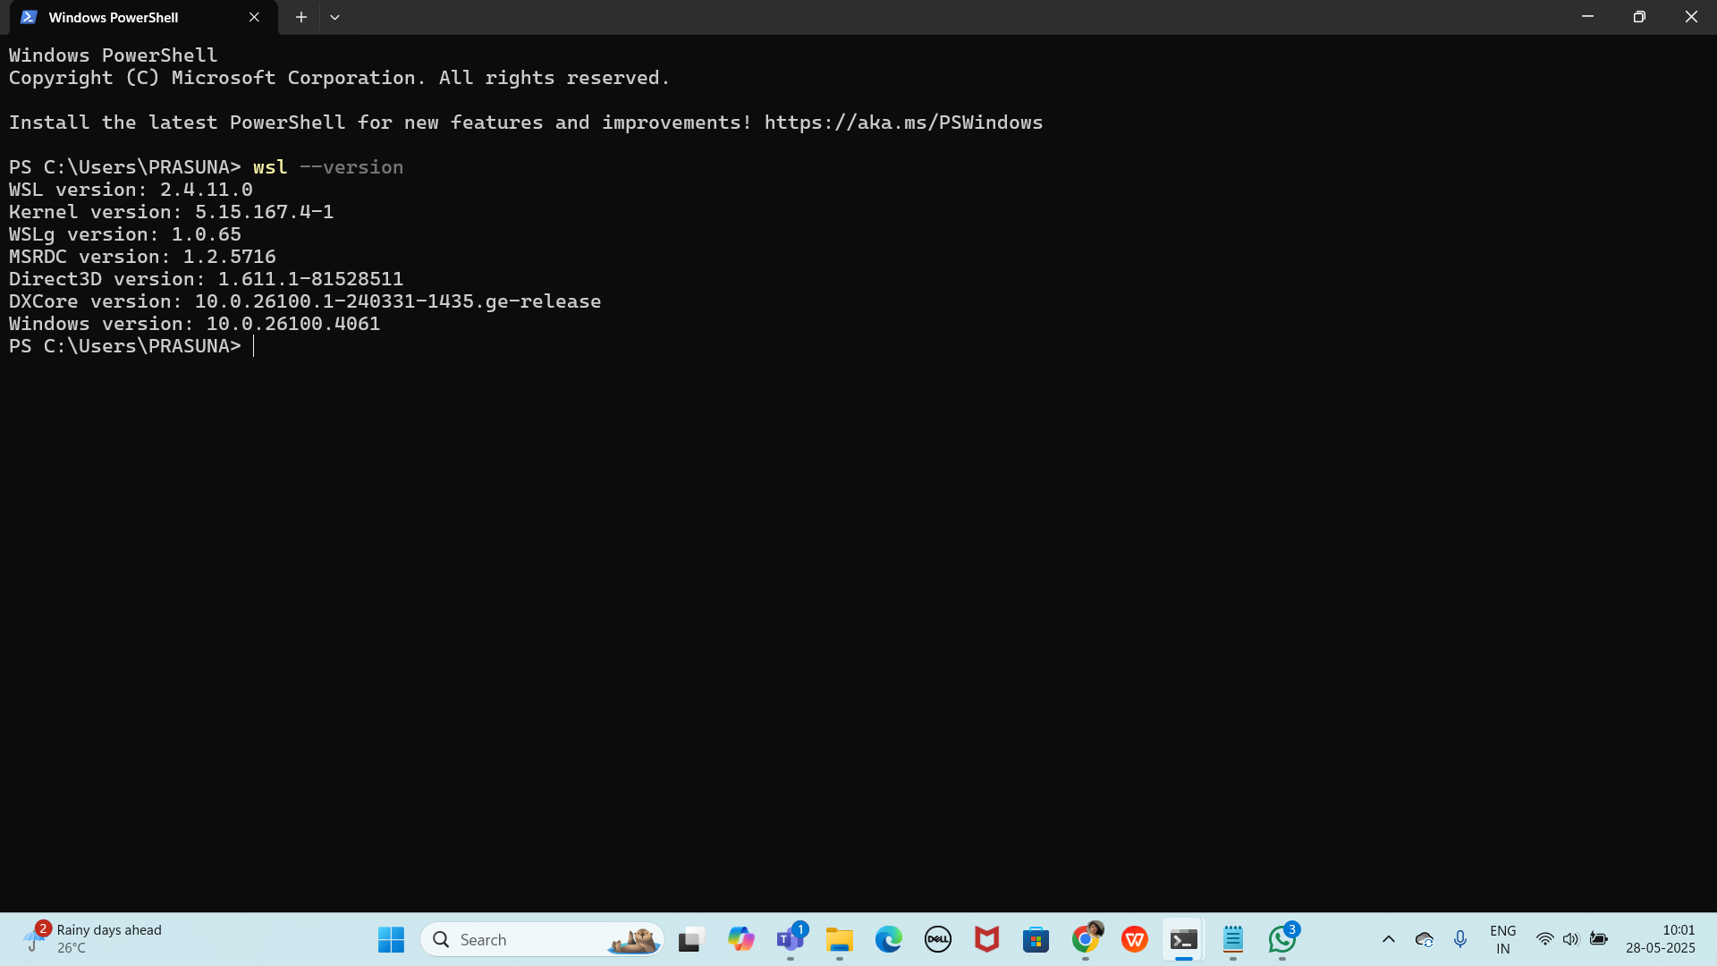

If not installed try to use below linux..

In cmd:

wsl

Install linux
https://learn.microsoft.com/en-us/linux/install
Task 1:
Create a Directory with the Name Linux Practice.
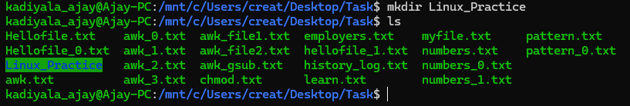
Task2:
Change to the directory
Task 3:
Create a file named TestFile1.txt and add the content to it.
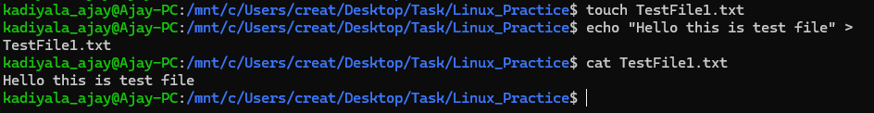
Task 4:
Create a Folder named Dummy and try to delete
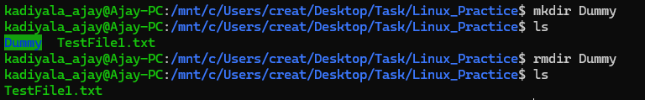
Task 5:
Plz check the working directory (Hint : pwd)
Task 6:
How do you check all the files and directories in the directory you are in?
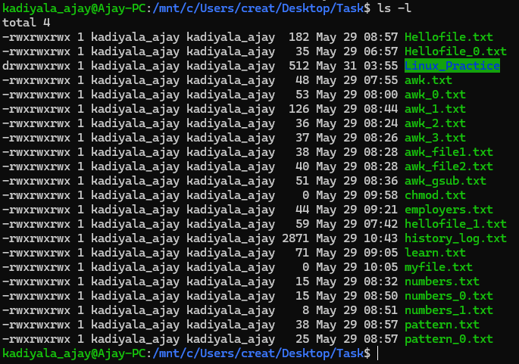
Task 7:
Create five files named TestFile2.txt.. TestFile3.txt… and so on till TestFile6.txt
Task 8:
Copy all files from Dir 1 ti Dir 2
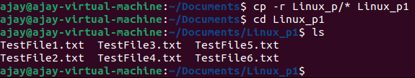
Task 9:
Move all files from Dir 2 to Dir 3 (finally ur Dir 2 should be empty)
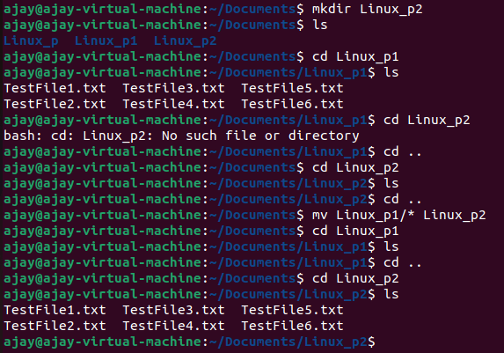
Task 10:
Can you plz show me the difference between rm and rmdir commands with screenshots ?
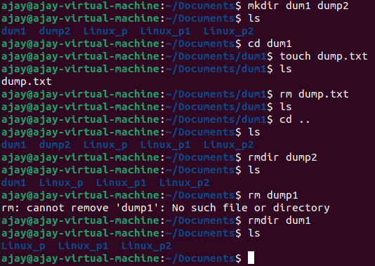
- rm (Remove)
  - This command is used to delete files.
  - In the image, when rm dump.txt was executed inside dum1, the file was successfully removed.
  - However, trying rm dum1 fails because dum1 is a directory. The rm command, by itself, only works for files.
- rmdir (Remove Directory)
  - This command is used to delete directories.
  - In the image, after dump.txt was deleted, rmdir dum1 was used to remove the directory.
  - Similarly, rmdir dum2 was also used successfully to delete another directory.
Ok now open Lorem Ipsum in your browser

https://www.lipsum.com/ u can use this link for random text..

Task 11:

Now use specifically use cat command to create a file

And add the dummy text from the above link Lorem Ipsum.
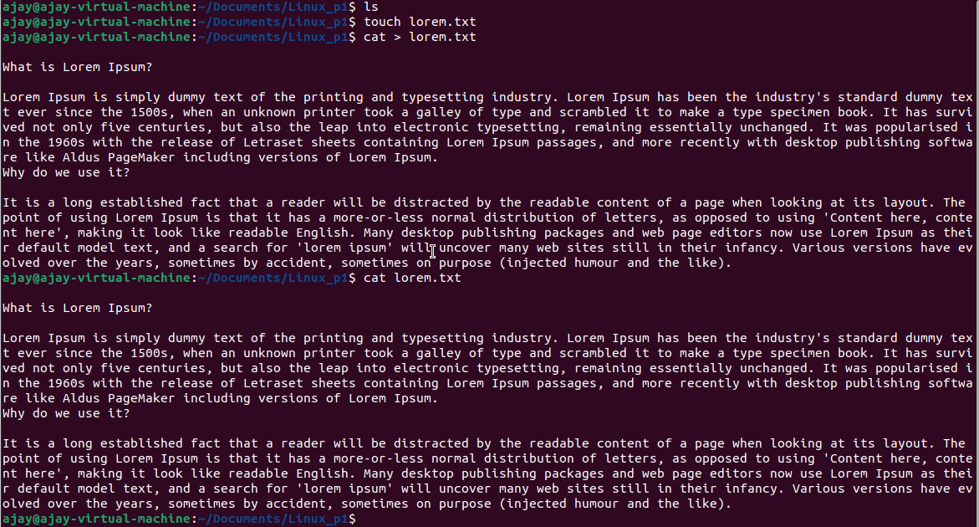

Task 12:

How to get only the top part of your file..
Hint: use head
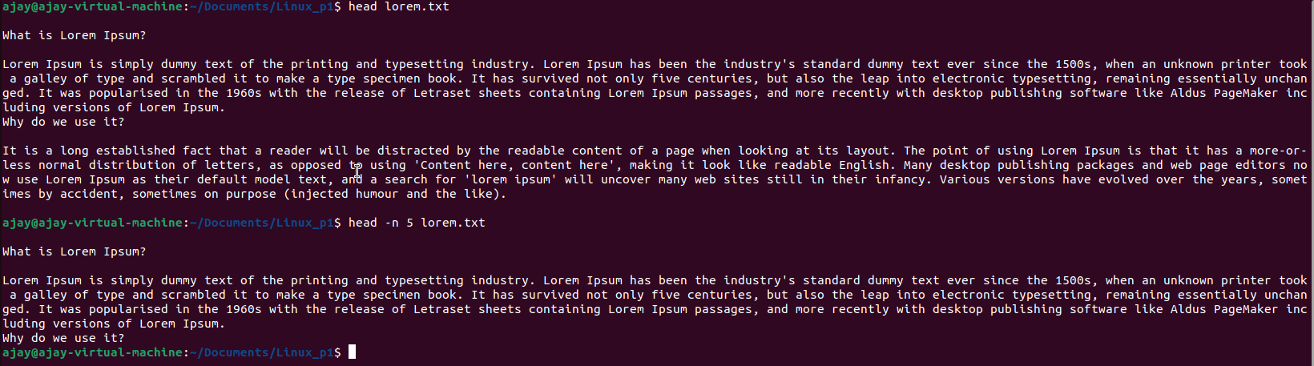

Task 13:

How to get only the last part of your file
Hint: use tail
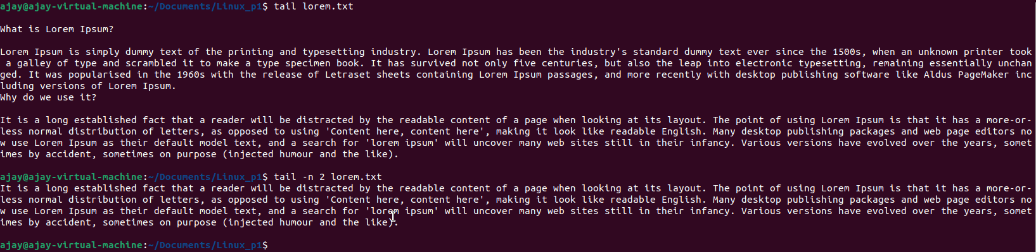
Task 14:

Plz add dummy text of 5 to 6 pages in to the same file

And
Now show the file in page by page

Hint : use less command
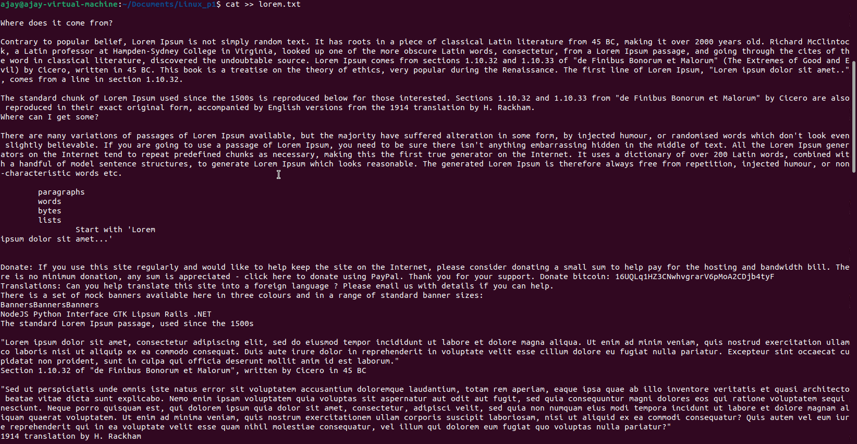
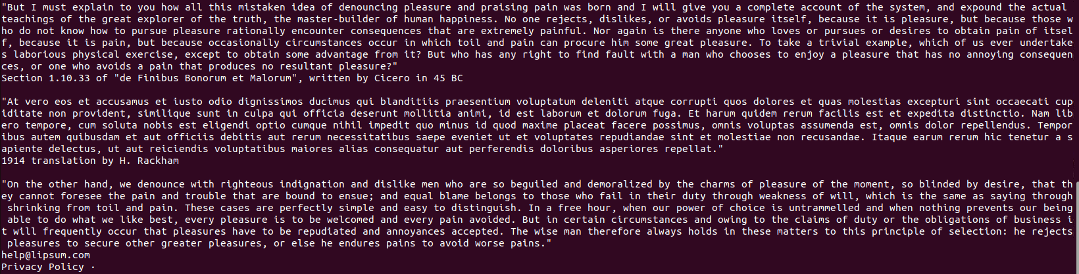
To view page by page:
Command:
After pressing enter:
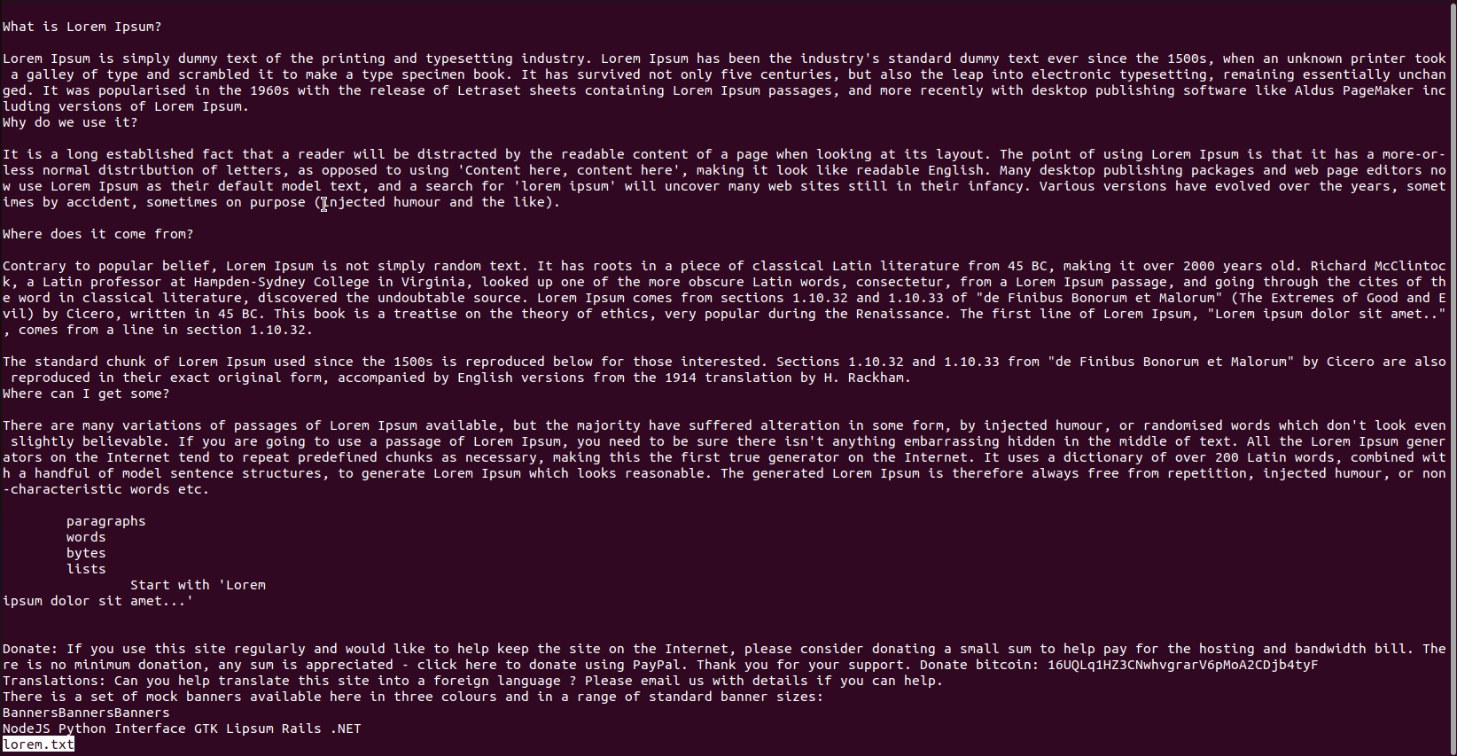
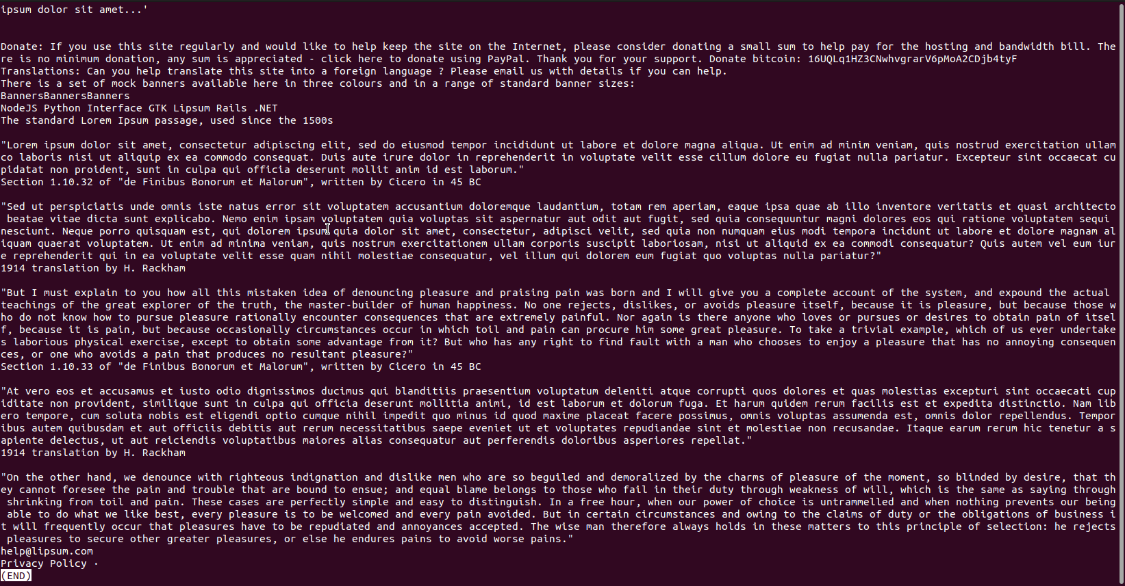

- Press Space to move to the next page.
- Press b to move back.
- Press q to exit.

Task 15:

Use more command on the above file and find out the diff between less command and more command.

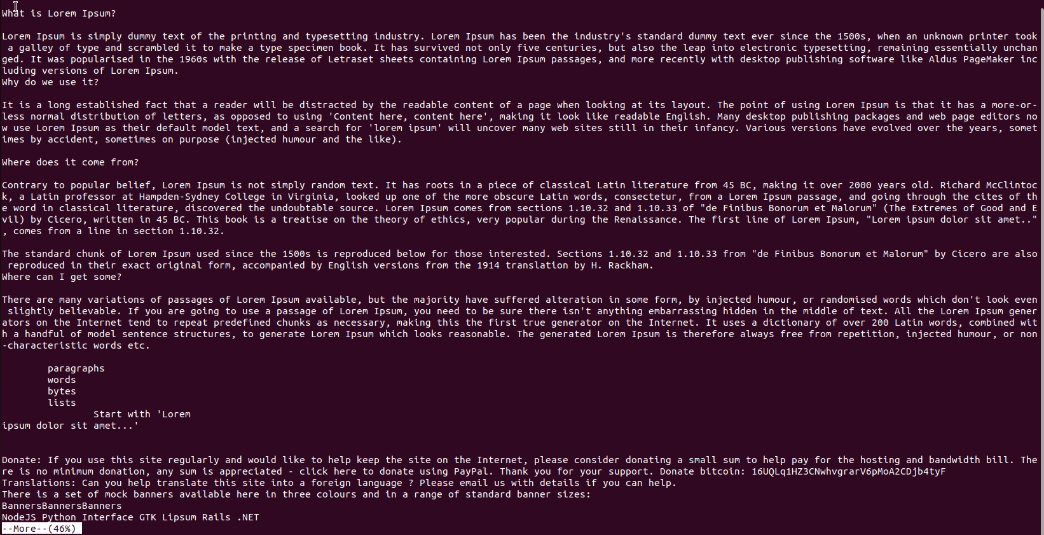
More: Displays the file one page at a time. We can only move forward (no scrolling backward).

- Press Space to move to the next page.
- Press Enter to move one line at a time.
- Press q to exit.

Less: More advanced than more —allows scrolling both forward and backward.
- Press Space to move forward.
- Press b to move backward.
- Press q to exit.

What is e in echo command..?
The e in the echo command is an option that enables the interpretation of backslash escape sequences. These sequences allow you to insert special characters and formatting into the output.

Task 16:
Can you use the echo command with -e and see the diff.. Also take a ss and paste .
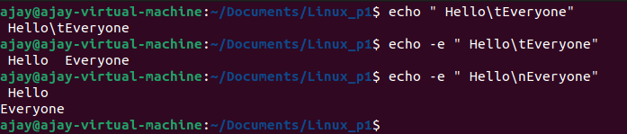
The -e option in echo enables interpretation of escape sequences,
Examples:
- \n: Newline (moves the cursor to the next line)
- \t: Tab (moves the cursor to the next tab stop)
Task 17:
What is the difference between ls and ls -l command .. ss plz
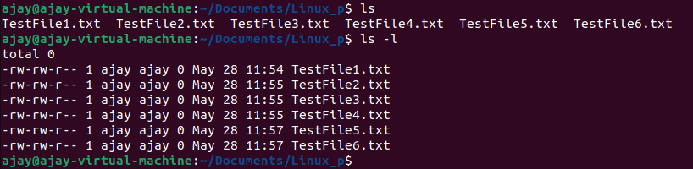
ls # Lists files and folders
ls -l # Lists details like permissions, owner, file size, and modified date

Task 18:

Create a file using touch command , cat command and echo command and take ss (screen shot)..
Also write the difference between touch , cat and echo commands.
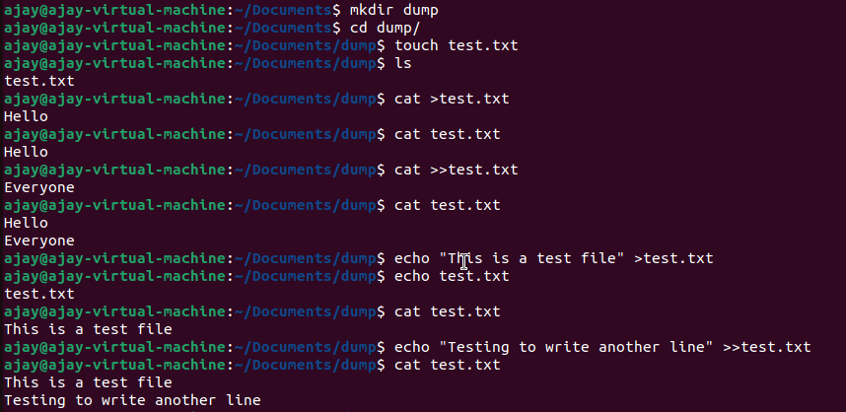
touch creates an empty file without adding content.
cat allows you to create a file while manually entering text and later viewing the content.
echo write predefined text into a file immediately
the differences between touch, cat, and echo commands by executing in terminal:
- touch filename.txt creates an empty file without adding content.
- cat > filename.txt allows manual text entry into the file. After typing, We likely pressed Ctrl+D to save the input.
- echo "Some text" > filename.txt writes predefined text into the file immediately, replacing any existing content.
- In Both cat & echo to append something we use >>.
Task 19:
Can you guys try to display the calendar by using a command..
Hint: use cal
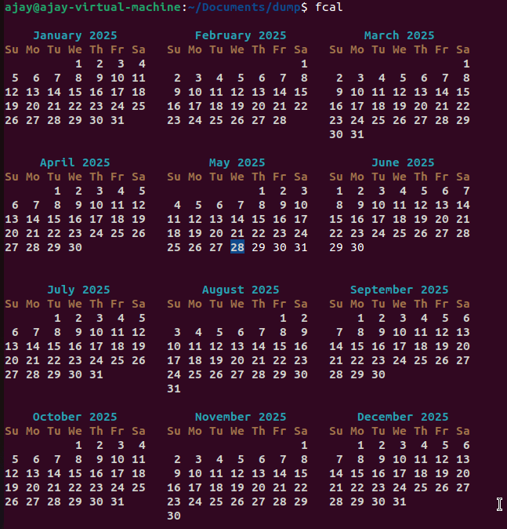

To display a calendar using the cal command
To display a specific year's calendar using the cal 2025 command
To display a specific month and year calendar using the cal 5 2025 command

Task 20:
Can you go back to 1 directory .. at a time whats the command
cd .. # To go back one directory
cd ../.. # To go back two directories, Each .. represents going up one level.
cd / # To go straight to the root

Task 21:
How to know whose user you are working on ?
Hint: use whoami command
whoami command will output the username associated with the active session.
Id command will show the UID, primary group, and any additional groups the user belongs to
Task 22:
Try to find out who is peeping into your system..
Use users, who and w commands with ss
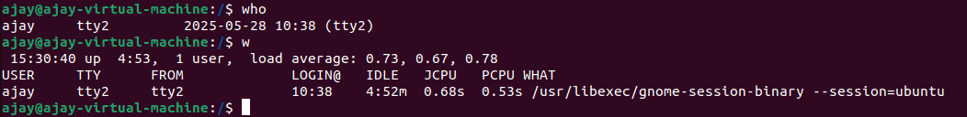

Task 23:

Can you guys try to check how much disk space is consumed..
Hint : use df -h
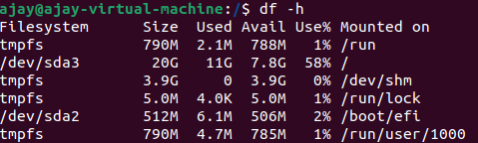

Task 24:

Can you plz try using the below commands
- -rw-r--r-- → Regular file (-) drwxr-xr-x → Directory (d)
- brw-r--r-- → Block device (b)
- crw-r--r-- → Character device (c)
- lrwxrwxrwx → Symbolic link (l)
- prw-r--r-- → Named pipe (p)
- srwxr-xr-x → Socket (s)

Prefix | Description
- | Regular file, such as an ASCII text file, binary executable, or hard link.
b | Block special file. Block input/output device file such as a physical hard drive.
c | Character special file. Raw input/output device file such as a physical hard drive.
d | Directory which contains a listing of other files and directories.
l | Symbolic link file. Links on any regular file.
p | Named pipe. A mechanism for interprocess communications.
s | Socket which is used for interprocess communication.

Task 25:

Find the list of all files ending with .txt
Hint : use * in ls
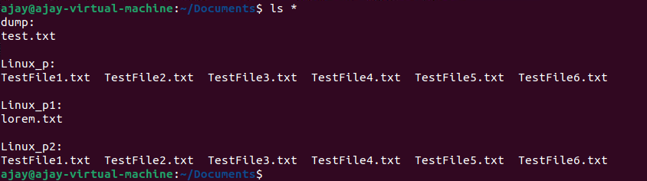

Task 26:

In Linux all the hidden files start with . (period)

How to check all the hidden files in Linux..

Hint : use ls -a

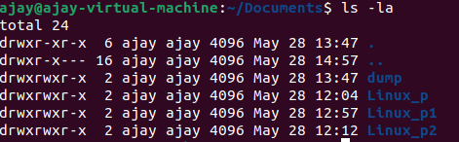
ls -a # This displays all files, including hidden ones
ls -la # This provides permissions, ownership, and other details.

Task 27:
What is the difference between . and .. in linux
Line 1 line for each
. refers to the current directory,
.. refers to the parent directory.
Task 28:

Can you create a file using vi editor and show the details in ss

Hint:
Esc is for come out of the edit mode
Press two keys Shift &plus; ZZ together to come out of the file completely
- I - to insert
To move inside the file
- l key to move to the right side.
- h key to move to the left side.
- k key to move upside in the file.
- j key to move downside in the file.

Task 29:
How to find the no of words in the file
Hint: use wc
Here is the detail of all the four columns of wc command −
- First Column − Represents the total number of lines in the file.
- Second Column − Represents the total number of words in the file.
- Third Column − Represents the total number of bytes in the file. This is the actual size of the file.
- Fourth Column − Represents the file name.
Task 30:
What is the use of cat -b myfilename.txt command?

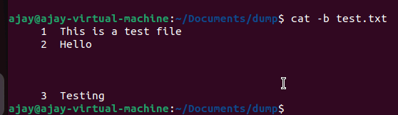
The cat -b myfilename.txt command is used to display the contents of test.txt while numbering only non-empty lines.
Here's how it works:
- It prints each line of the file.
- Empty lines remain unnumbered.
- Non-empty lines are prefixed with a number

Task 31:

Can I use the wc with 2 or more files?
Wc file1 file2 file3
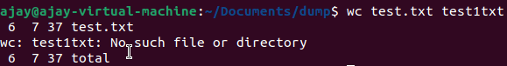

Task 32:
How to copy content of one file to another file
Hint: use cp:
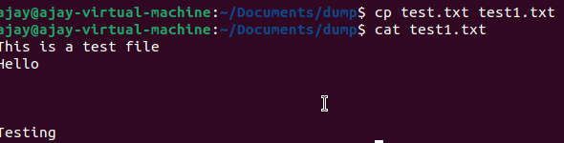
Task 33:

Now I want to rename my file with MYFILENEW can i do that if so how ?
Hint use : mv

Task 34:

Can I remove or delete multiple files in linux..? How?
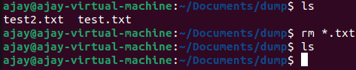

Task 35:
In the directory / slash is root … Can you try cd / what is it doing?

Linux directory structure: plz have a reading and try to remember..

Directory | Description
/bin | important binary applications
/boot | boot configuration files, kernels, and other files needed at boot time.
/dev | System device files.
/etc | configuration files, startup scripts, etc.
/home | List of home directories for different users
/lib | system libraries, shared libraries
/lost+found | a lost+found system for files that exist under the root (/) directory
/media | automatically mounted (loaded) partitions on your hard drive and removable media such as CDs, digital cameras, etc.
/mnt | manually mounted filesystems on your hard drive
/opt | 3rd part applications to be installed
/proc | Maintains information about the state of the system, including currently running processes.
/root | root user's home directory.
/sbin | important system binaries
/srv | contain files that are served to other systems
/sys | system files
/tmp | temporary files
/usr | applications and files that are mostly available for all users to access
/var | variable files such as logs and databases

Task 36:

What is the way go go to home directory ?

Hint : use cd ~
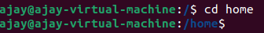

Task 37:
If i want to move to different users home directory

Hint : use ~username
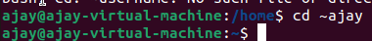

—---------------------------------------commands to work in linux —----------------------------------------

Basic Navigation & File Operations:
- cd: Change directory.
- pwd: Print working directory.
- ls: List directory contents.
- mkdir: Create a new directory.
- rmdir: Remove an empty directory.
- rm: Remove files or directories.
- cp: Copy files or directories.
- mv: Move or rename files or directories.
- touch: Create an empty file.

File Content Management:
- cat: Concatenate and display the contents of a file.
- head: Display the first part of a file.
- tail: Display the last part of a file.
- less: Display file contents, page by page.
- more: Display file contents, page by page.
System Information & Utility:
- uname: Print system information.
- whoami: Display the current user's name.
- date: Display the current date and time.
- cal: Display the calendar for a specified month or year.
- df: Display disk space usage.
- du: Display disk space usage for a specific directory.
- top: Display real-time processor activity.
- man: Access the command manual.
- grep: Search for patterns within files.
- echo: Print text to the terminal.
Other Useful Commands:
- sudo: Execute a command with superuser privileges.
- chmod: Change file permissions.
- chown: Change file ownership.
- tar: Create archives.
- gzip: Compress or decompress files.
- unzip: Unzip archives.
- zip: Create zip archives.

